***DYNAMIC MEMORY ALLOCATION***

***INTEGER***

#include <iostream>

using namespace std;

int main()

{

int *p=new int;

*p=10;

cout<<*p;

delete p;

}

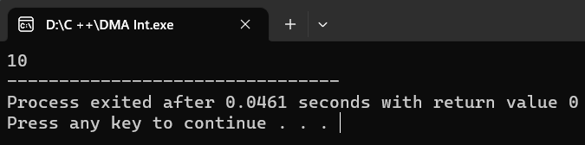

***CHARACTER***

#include <iostream>

using namespace std;

int main()

{

char *p=new char;

*p='s';

cout<<*p;

delete p;

}

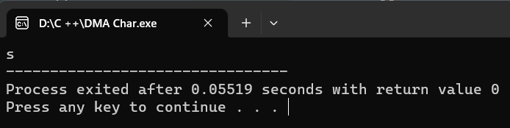

***FLOAT***

#include <iostream>

using namespace std;

int main()

{

float *p=new float;

*p=10.5;

cout<<*p;

delete p;

}

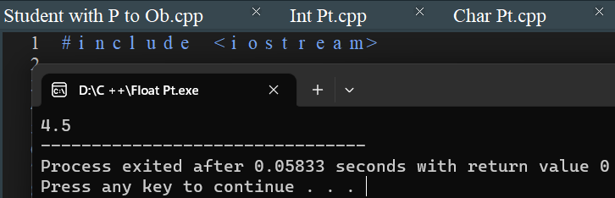

***DOUBLE***

#include <iostream>

using namespace std;

int main()

{

double *p=new double;

*p=10.453;

cout<<*p;

delete p;

}

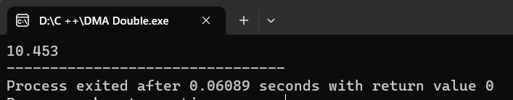

***STRING***

#include <iostream>

#include <string>

using namespace std;

int main()

{

string *p=new string;

*p="selva";

cout<<*p;

delete p;

}

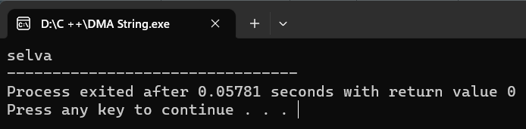

***ARRAY***

#include <iostream>

using namespace std;

int main()

{

int *p=new int[5];

for(int i=0;i< 5;i++) {

cin>>p[i];

}

for(int i=0;i<5;i++) {

cout<<p[i];

}

delete[]p;

return 0;

}

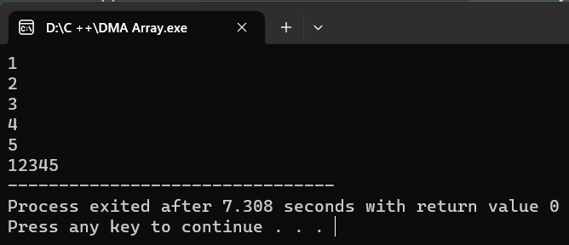

***ARRAY ADD***

#include <iostream>

using namespace std;

int main() {

int n;

cout<<"Enter the Size: ";

cin >> n;

int *p = new int[n];

cout<<"Enter the Values:\n";

for (int i = 0; i < n; i++) {

cin >> p[i];

}

cout<<"The Values Are: ";

for (int i = 0; i < n; i++) {

cout << p[i] << " ";

}

delete[] p;

return 0;

}

